LAB 5

Exercise 1 — Overload print()
File: PrintDemo.java
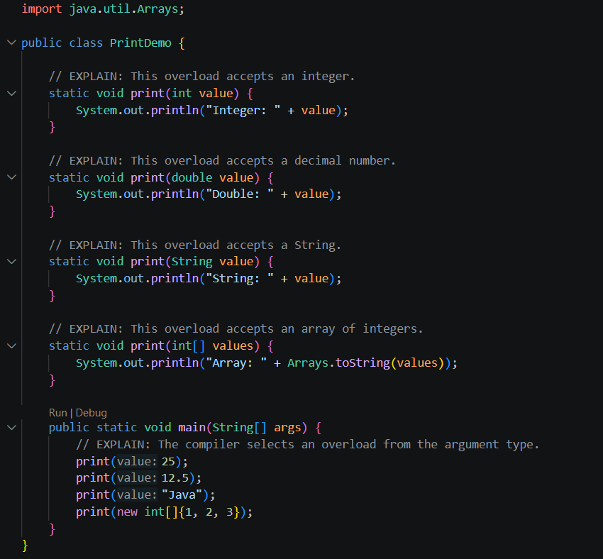
Output:
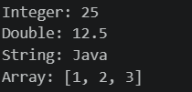

Exercise 2 — Animal, Cat, Cow, and Duck
File: AnimalDemo.java
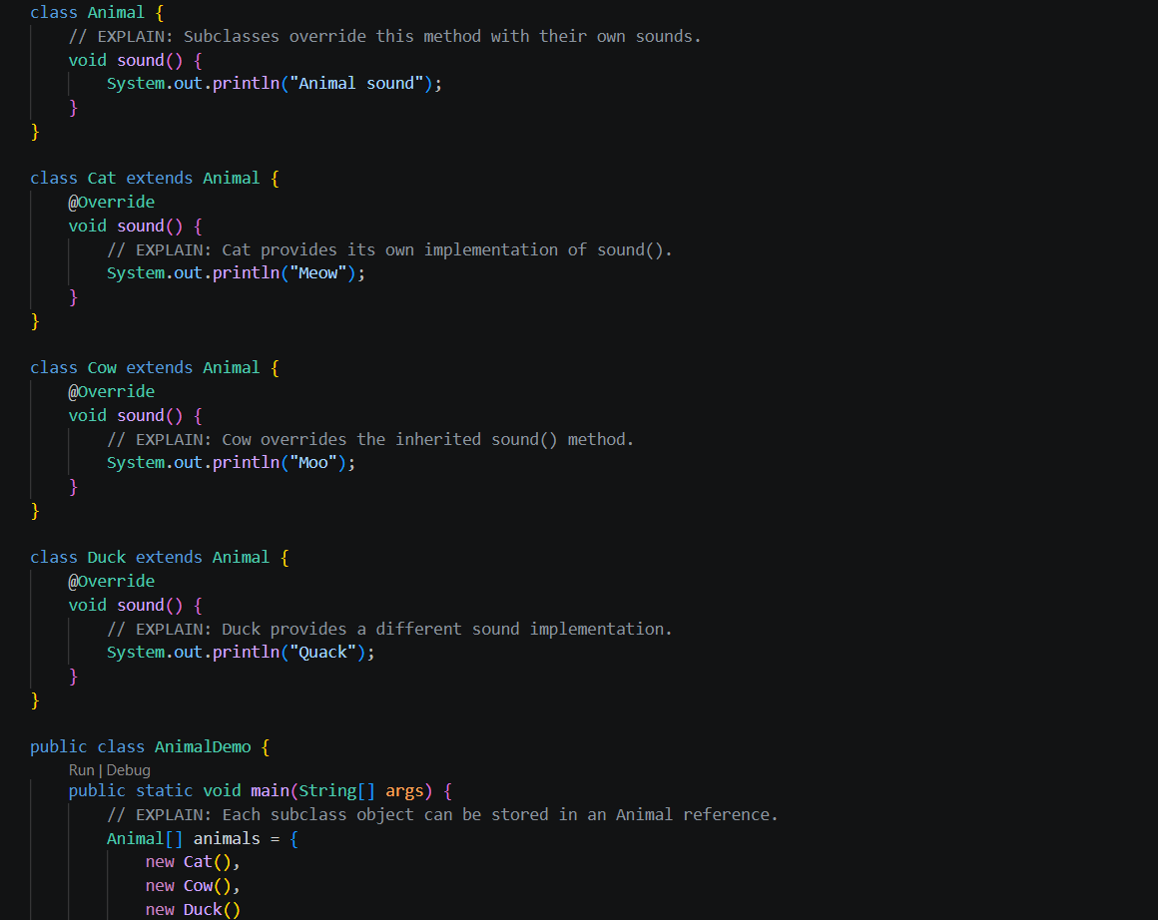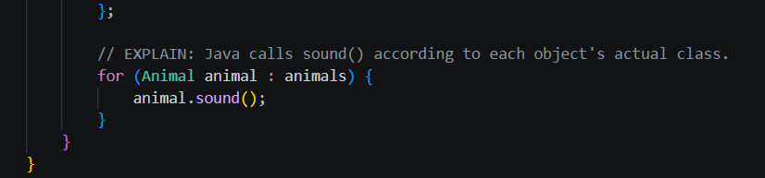
Output:
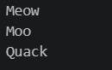

Exercise 3 — Add Intern to the Lab 4 employee hierarchy
File: PayrollDemo.java
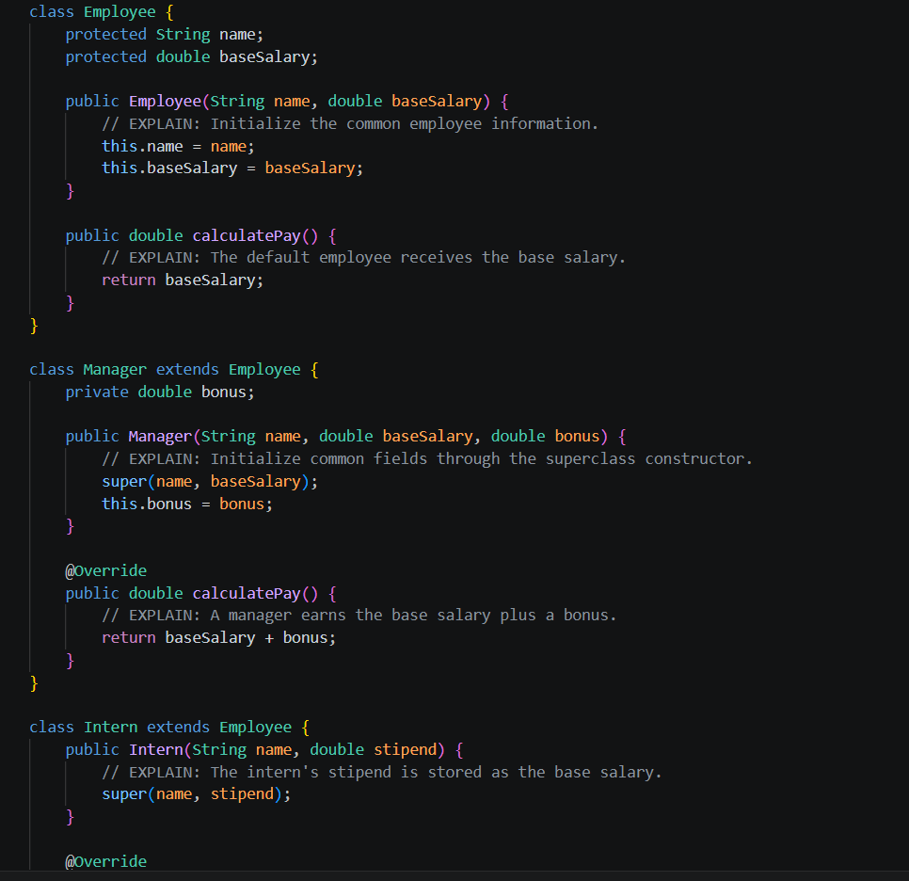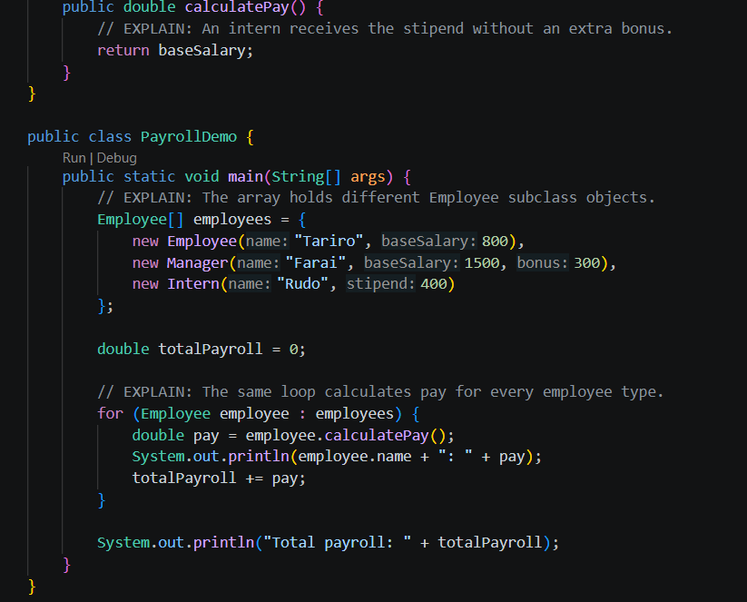
Output:
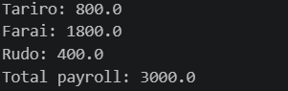

Exercise 4 — Method versus field through a superclass reference
File: ReferenceDemo.java
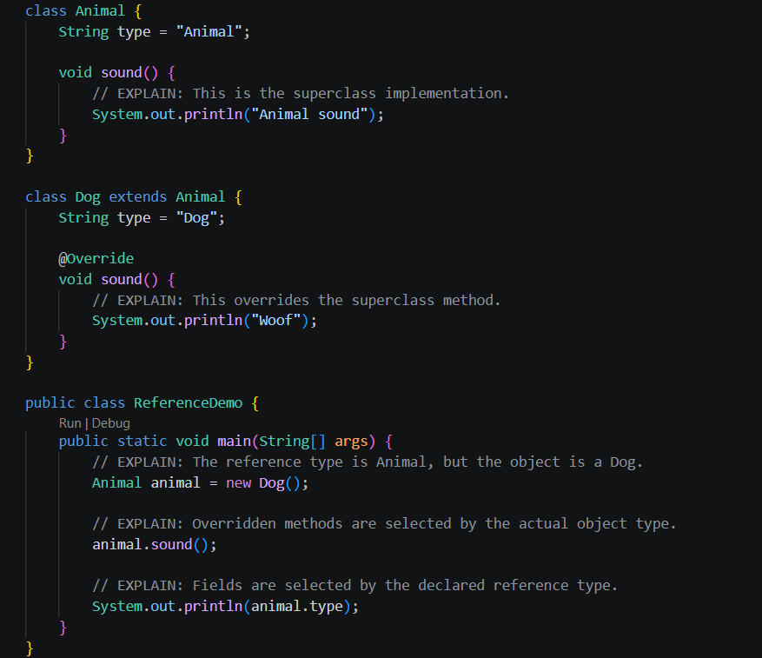
Output:
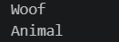
Explanation
sound() is overridden, so runtime polymorphism calls Dog.sound(). The type field is hidden, not overridden, so animal.type accesses the field declared in Animal.

Exercise 5 — Payment processing: instanceof versus polymorphism

Version A: Using instanceof
File: PaymentDemo.java
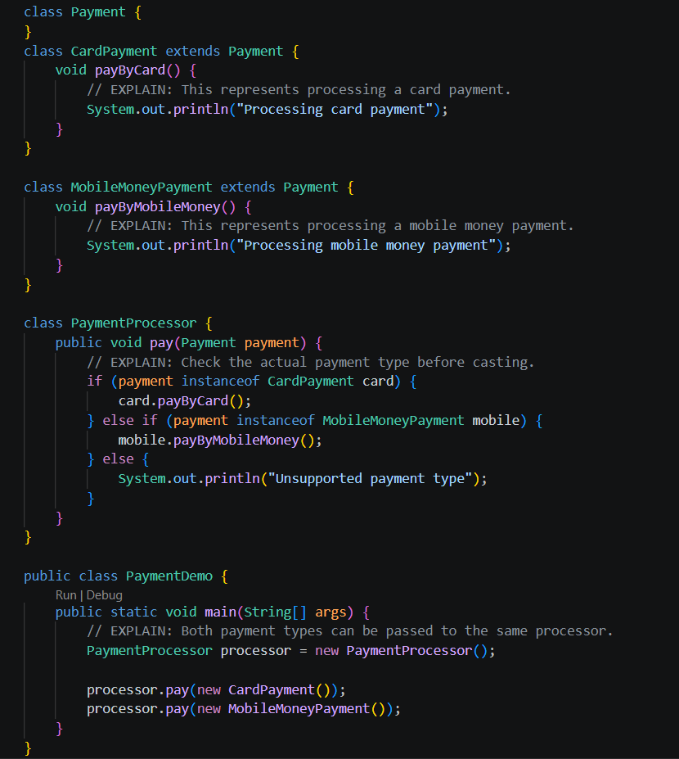
Output:
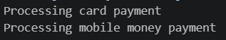
Version B: Refactor to polymorphic process()
File: PaymentDemo.java
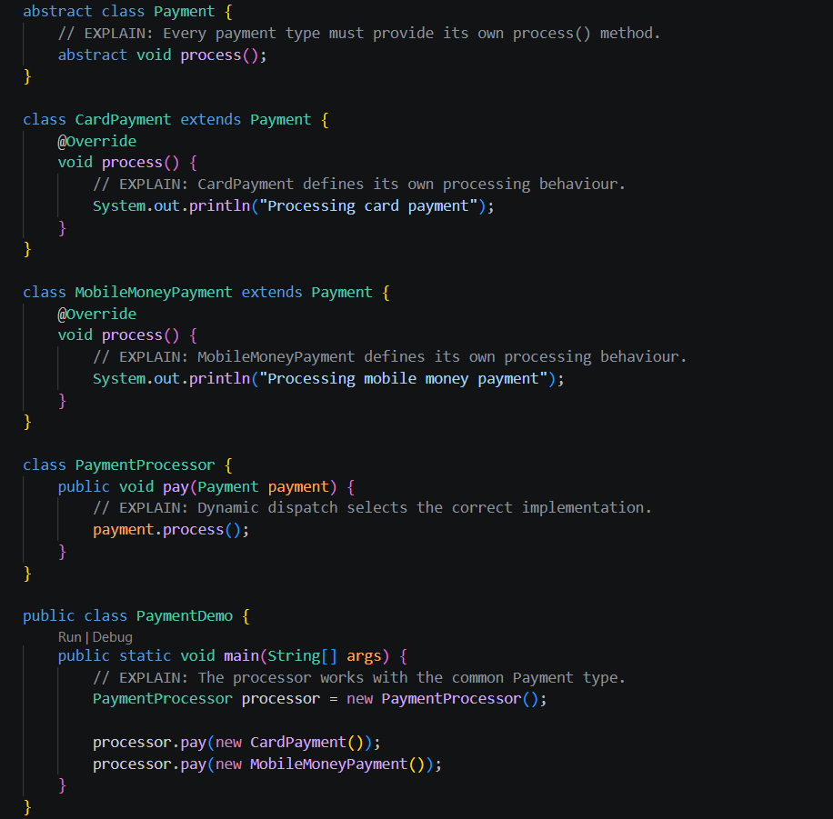
Output:
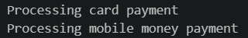
Comparing the 2 versions
- instanceof version: The processor must check every payment type and add another branch whenever a new type is introduced.
- Polymorphic version: Each payment class implements process(). The processor remains unchanged when new payment types are added, provided they extend Payment and implement the method.

